Swapping of Variables
Aim: To swap values with and without using a third variable.
#include <stdio.h>
int main() {
printf("Name : Priyanshi\n");
printf("URN : 268100547\n");
int a, b, temp;

printf("Enter two numbers for a and b: ");
scanf("%d %d", &a, &b);

// using third variable
printf("Before: a = %d, b = %d\n", a, b);
temp = a;
a = b;
b = temp;
printf("After (with temp): a = %d, b = %d\n", a, b);

// without third variable (re-calculating using user inputs)
a = a + b;
b = a - b;
a = a - b;
printf("After (without temp): a = %d, b = %d\n", a, b);

return 0;
}

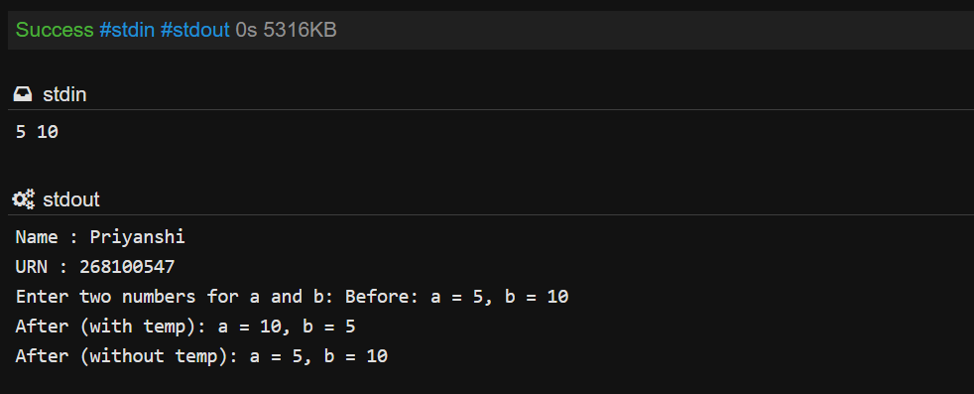

Simple Calculator (Switch Case)
Aim: Take two numbers and an operator (+, -, *, /) from the user. Use switch-case to perform the operation and print the result.
#include <stdio.h>
int main() {
printf("Name : Priyanshi\n");
printf("URN : 268100547\n");
char op;
int a = 8, b = 2;
printf("Enter operator (+, -, *, /): ");
scanf("%c", &op);
switch(op) {
case '+': printf("Output: %d", a + b); break;
case '-': printf("Output: %d", a - b); break;
case '*': printf("Output: %d", a * b); break;
case '/': printf("Output: %d", a / b); break;
default: printf("Invalid operator");
}
return 0;
}

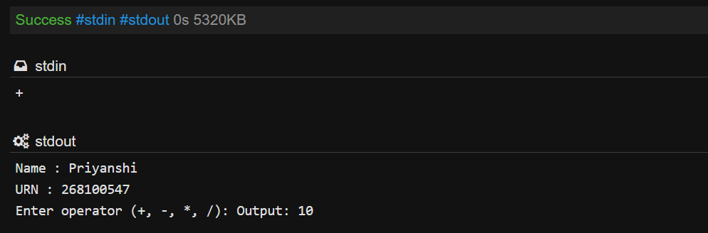

Day of the Week (Switch Case)
Aim: Take a number from 1 to 7 and use switch-case to print the day name (1 = Monday ... 7 = Sunday). Print "Invalid" for any other number.
#include <stdio.h>
int main() {
printf("Name : Priyanshi\n");
printf("URN : 268100547\n");
int day;
printf("Enter day number: ");
scanf("%d", &day);

switch(day) {
case 1: printf("Monday"); break;
case 2: printf("Tuesday"); break;
case 3: printf("Wednesday"); break;
case 4: printf("Thursday"); break;
case 5: printf("Friday"); break;
case 6: printf("Saturday"); break;
case 7: printf("Sunday"); break;
default: printf("Invalid");
}
return 0;
}

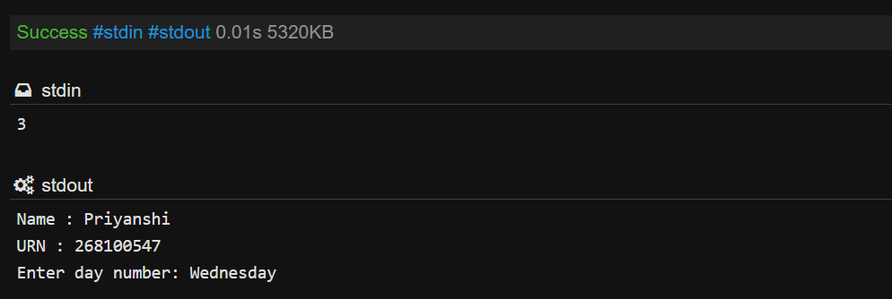

Sum of First N Numbers (Loop)
Aim: Take a number n and use a loop to find the sum of all numbers from 1 to n.
#include <stdio.h>
int main() {
printf("Name : Priyanshi\n");
printf("URN : 268100547\n");
int n, sum = 0;
printf("Enter n: ");
scanf("%d", &n);
for(int i = 1; i <= n; i++) {
sum = sum + i;
}
printf("Output: %d\n", sum);
return 0;
}

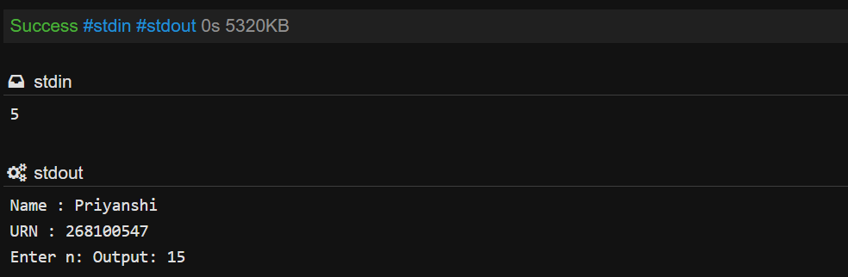

Factorial of a Number (Loop and Recursion)
Aim: Find the factorial of n. Solve it first using a loop, then again using a recursive function.
#include <stdio.h>
// recursive function
int fact(int n) {
if(n == 0 || n == 1) return 1;
return n * fact(n - 1);
}
int main() {
printf("Name : Priyanshi\n");
printf("URN : 268100547\n");
int n, loopFact = 1;
printf("Enter n: ");
scanf("%d", &n);
// using loop
for(int i = 1; i <= n; i++) {
loopFact = loopFact * i;
}
printf("Output using loop: %d\n", loopFact);
// using recursion
printf("Output using recursion: %d\n", fact(n));
return 0;
}

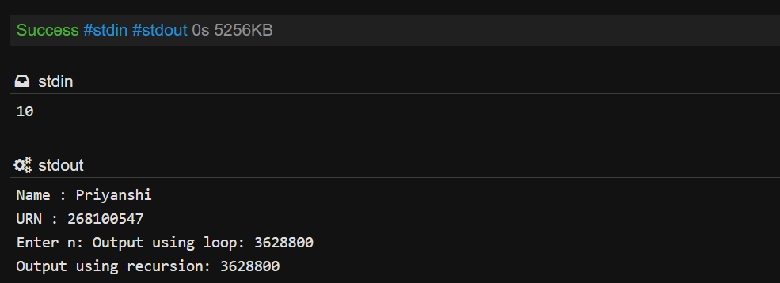

Even and Odd Sum (Loop)
Aim: Take a number n and find the sum of all even numbers and the sum of all odd numbers from 1 to n separately.
#include <stdio.h>
int main() {
printf("Name : Priyanshi\n");
printf("URN : 268100547\n");
int n, evenSum = 0, oddSum = 0;
printf("Enter n: ");
scanf("%d", &n);
for(int i = 1; i <= n; i++) {
if(i % 2 == 0) {
evenSum = evenSum + i;
} else {
oddSum = oddSum + i;
}
}
printf("Even sum = %d, Odd sum = %d\n", evenSum, oddSum);
return 0;
}



